**PRACTICAL FILE**

**“FOUNDATIONS OF DATA SCIENCE LAB”**



**Submitted By:**

Student Name- KIRTY GUPTA

Enrollment No.- 03317711922

Branch & section- AI & DS-(A)

**Submitted To:**

PROF. DEEPALI VIRMANI

**CERTIFICATE**

This is to certify that Kirty Gupta of AI&DS-(A) (3rd semester), session 2022-26 , have completed her Practical File for “Foundations Of Data Science Lab” and has given a satisfactory account of it in the file containing record of lab work.

This practical file has been completed under the guidance of Prof. Deepali Virmani as per GGSIPU guidelines.

**Internal examiner:**

**External examiner:**

**ACKNOWLEDGEMENT**

I would like to express my special thanks of gratitude to our subject/lab teacher Prof. Deepali Virmani for their constant guidance and support in completing the practical file.

I would also like to extend my gratitude to the HOD of our department , Dr Deepali Virmani, for providing us with the faculty that was required.

The opportunity to do the these lab experiments has helped me improve my reasoning, solving as well as coding skills and I am really grateful to them.

KIRTY GUPTA (AI&DS-A , 3rd sem)

**TABLE OF CONTENTS**

|  |  |  |  |
| --- | --- | --- | --- |
| **S.NO** | **TITLE** | **DATE** | **T.SIGN** |
|  |  |  |  |
|  |  |  |  |
|  |  |  |  |
|  |  |  |  |
|  |  |  |  |
|  |  |  |  |
|  |  |  |  |
|  |  |  |  |
|  |  |  |  |
|  |  |  |  |
|  |  |  |  |
|  |  |  |  |
|  |  |  |  |
|  |  |  |  |
|  |  |  |  |
|  |  |  |  |
|  |  |  |  |
|  |  |  |  |
|  |  |  |  |

**AIM:** TO PREPARE AND STUDY THE DATASET.

**QUESTIONARE:** ONLY FOR B.TECH CSE+GENERAL CATEGORY

1. Name of the college.
2. Location of the college
3. Establishment of college.
4. Which Entrance Exam required?
5. User Review On Faculty.
6. User Review On Placement.
7. User Review On Hostel.
8. User Review On Infrastructure.
9. User Review On Environment.
10. User Review On Academics.
11. College approved by?
12. Grading Of College? (out of 10)
13. Type of college?
14. Accreditation of the college.
15. Which counselling is required?
16. All girls or co-ed college?
17. Nearest metro connectivity to college.
18. Availability of Sports complex in college?
19. Availability of Canteen in college?
20. Number of societies available in college.
21. Name of the societies available in college
22. Campus area?
23. Number of hostels available in campus?
24. Car parking available or not?
25. Starting Rank?
26. Closing Rank?
27. Number of seats available?
28. Annual Fees of The Course?
29. Percentage of placements in college?
30. Average Package?

**DATASET:**

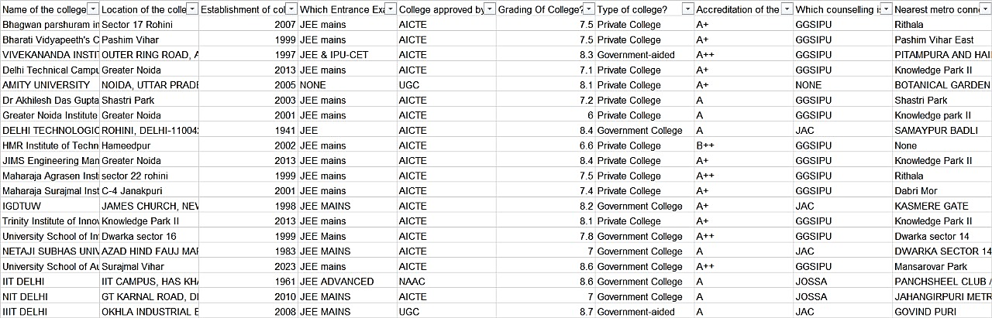

**5 QUERIES WITH PIVOT CHART**

1] Name and address of colleges having grade above 8 {name, address, grade}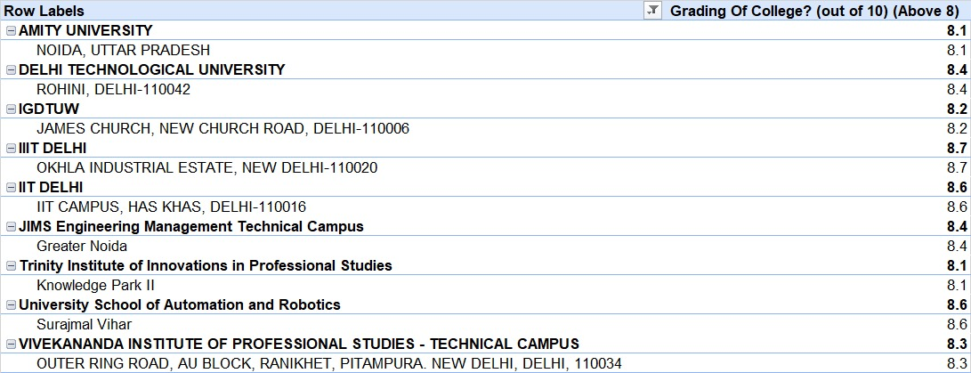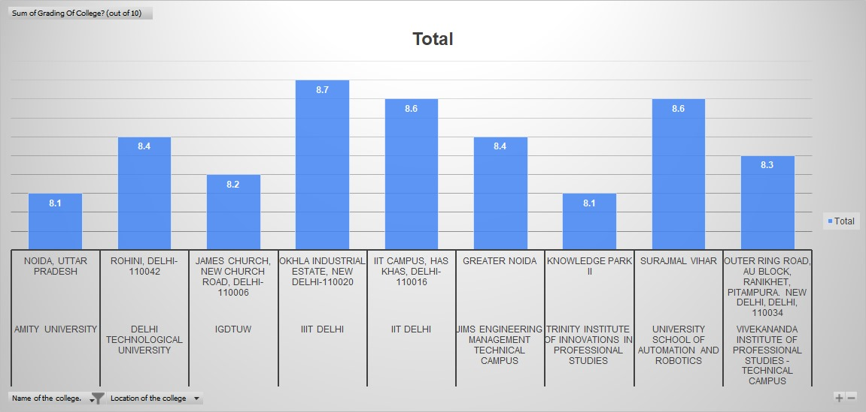

2] Name of the college established before 2005 and affiliated to AICTE {name, established, affiliation}

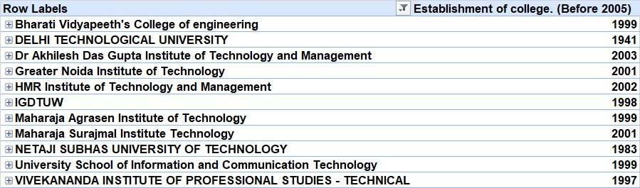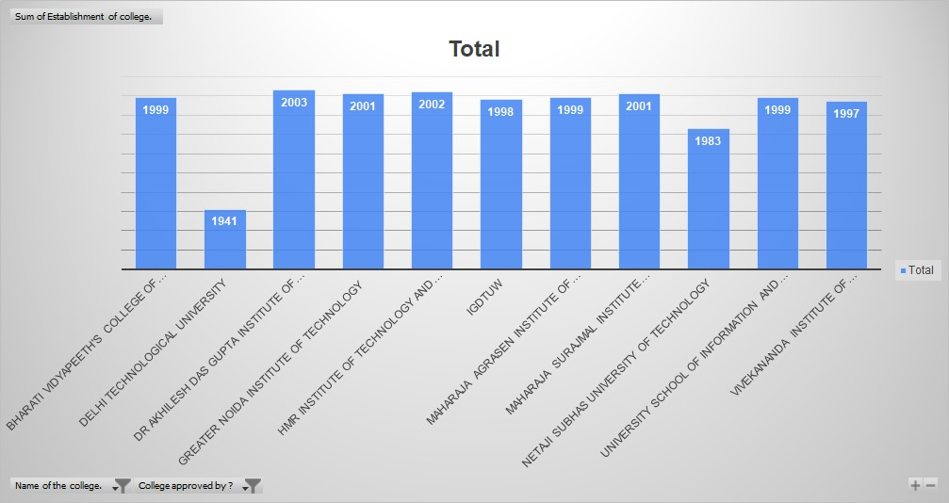

3] Name of colleges with seats more than 80 for closing rank above 100000 {name, seats, closing rank}

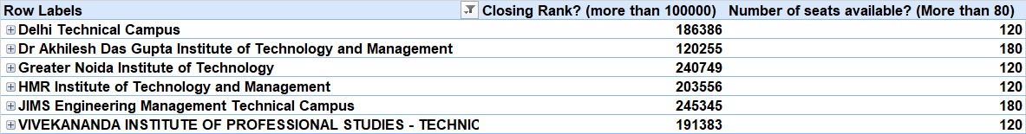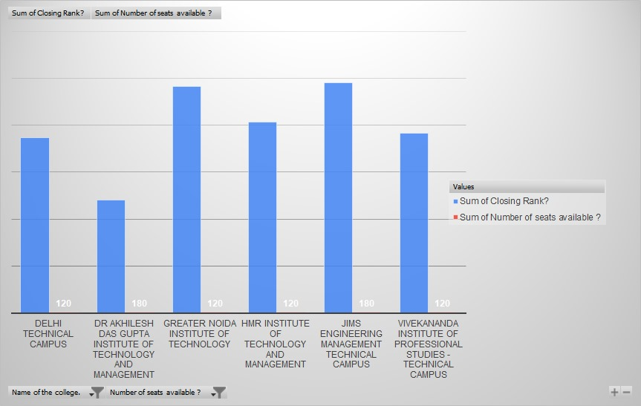

4] Name of colleges with annual fees less than 200000 and average placement more than 6LPA {name, annual fees, average placement}

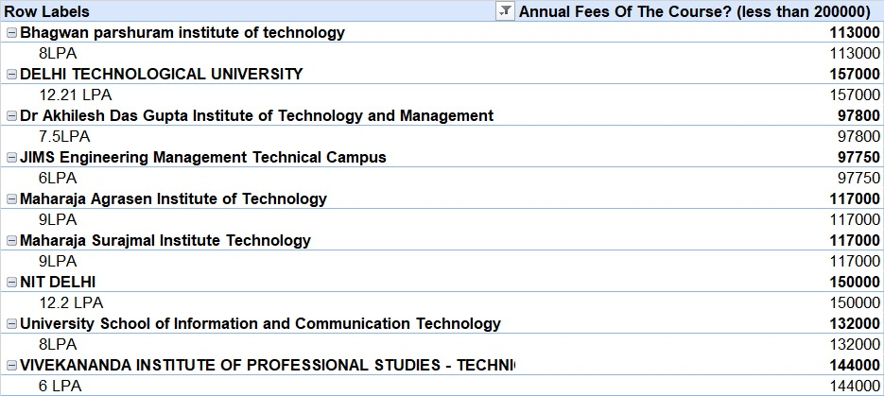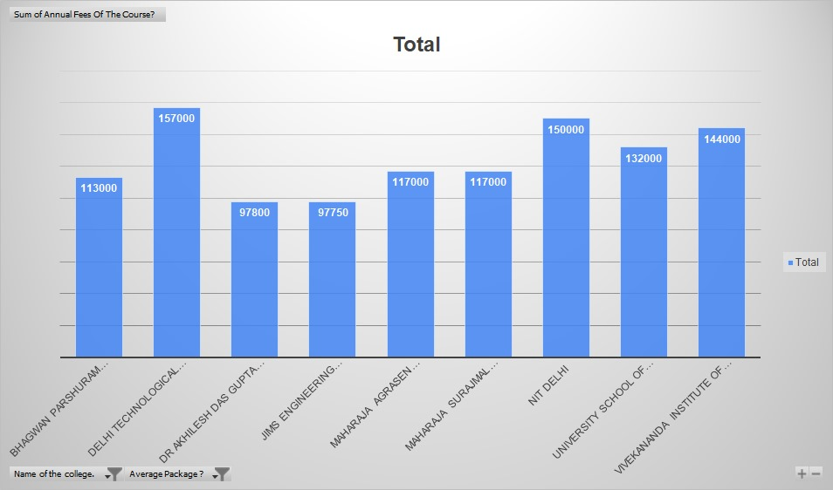

5] Name of government colleges having percentage of placement above 80% {name, type, placement%}

